**FIBONACCI SERIES :**

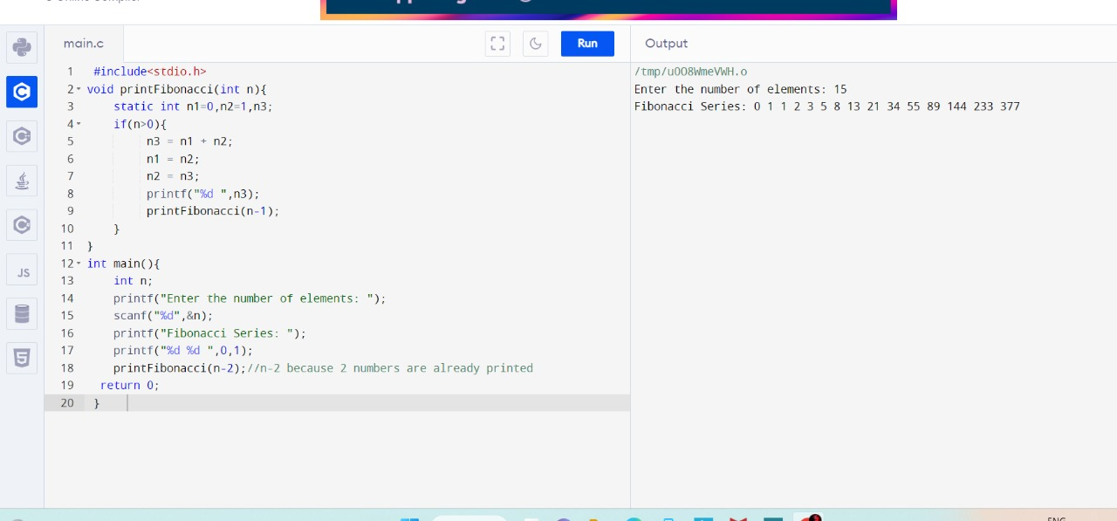

**ARMSTRONG OR NOT:**

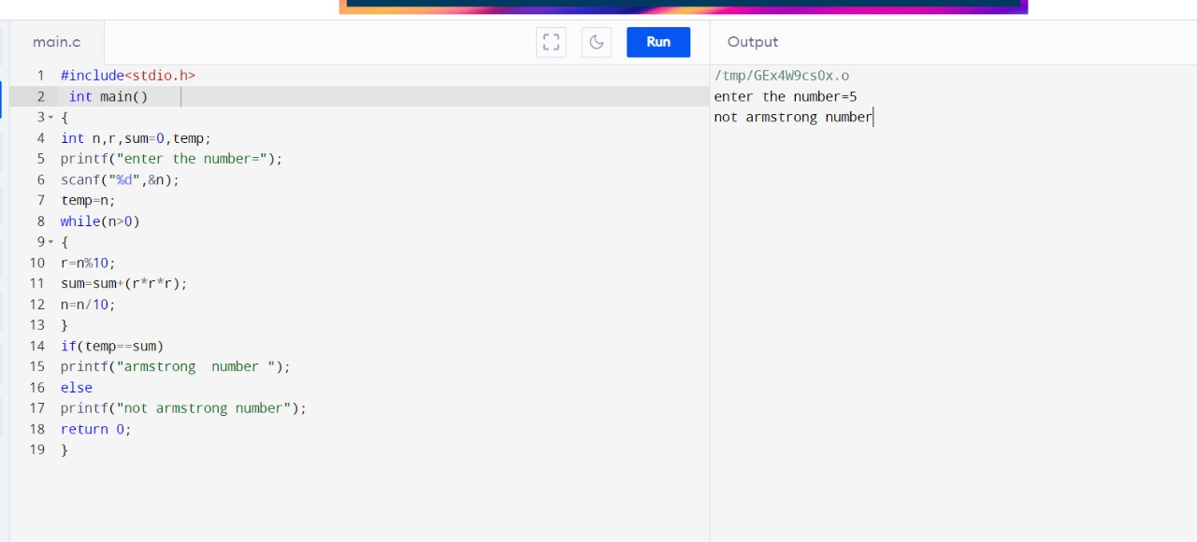

**GCD OF TWO NUMBERS:**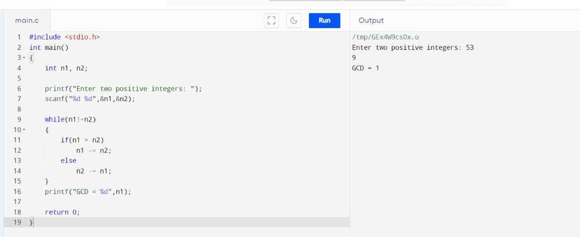

**LARGEST ELEMENT IN AN ARRAY:**

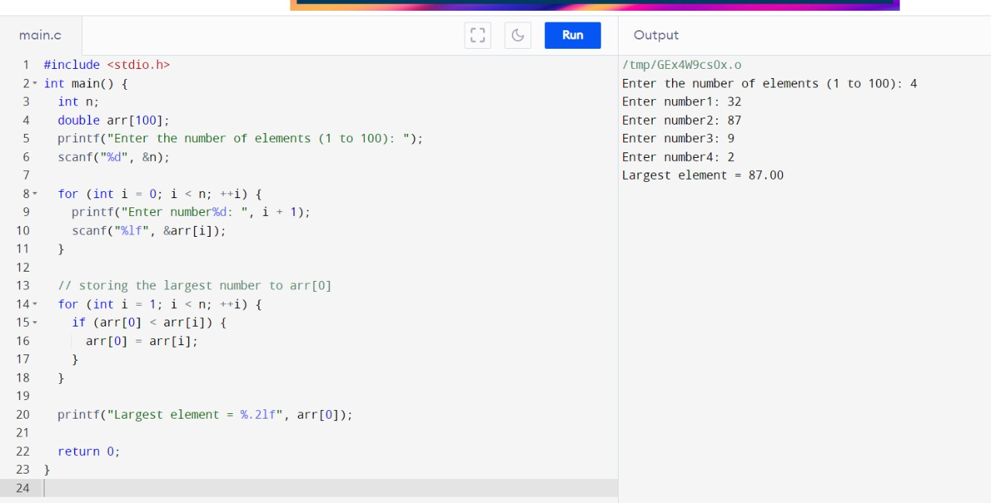

**FACTORIAL OF A NUMBER:**

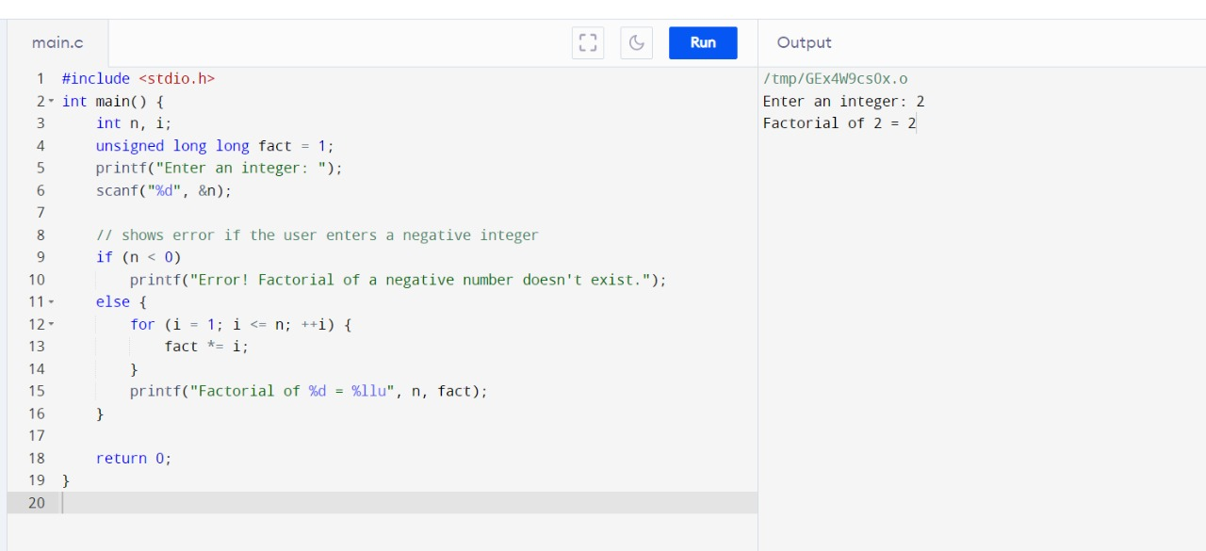

**PRIME NUMBER OR NOT:**

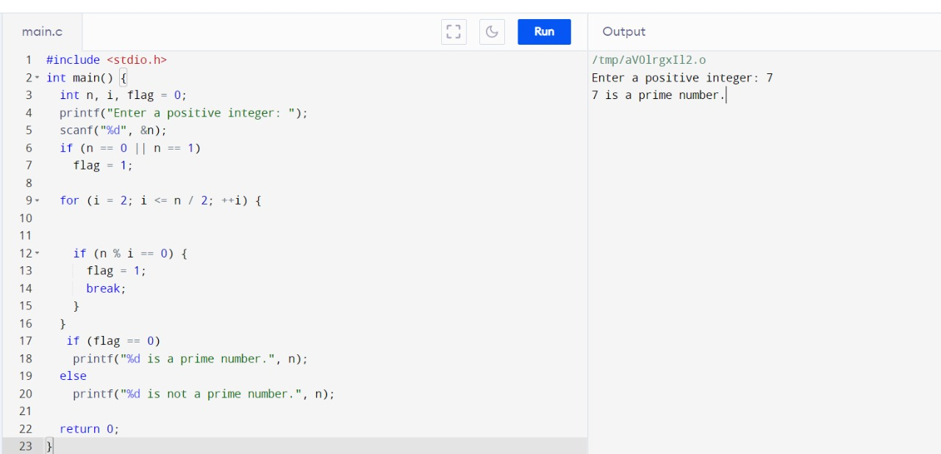

**SELECTION SORT:**

